**Template for the Honours Proposal**

Student Name

School of Design and Informatics

Abertay University

DUNDEE, DD1 1HG, UK

# ABSTRACT

This section is in the main body text of 9 point Times New Roman.

Insert here your Structured Abstract using the headings explained in the separate document.

(Approx ¼ of a page)

**Keywords**

Suggest a few keywords here that might be used to classify the topic of your project

**1. INTRODUCTION**

Insert your introduction text here. Remember that the introduction should set the scene for your project by describing a current situation or problem. Start in quite general terms so that your reader has a chance to align themselves but then focus towards the specifics of your chosen topic. Hopefully in this section it will become clear that there is a need for the work you are planning to carry out

Headings for the sections (INTRODUCTION etc) should be in 12 point Bold, Times New Roman. The main body of the text continues in 9 point Times New Roman.

You are advised to simply cut and paste your text into these sections and so preserve the formatting information

The page size is A4 , the top and bottom margins are 2.54cm and the left and right margins are 1.9cm. The document is in 2 columns each of width 8.2cm with a 0.8cm gutter; all of these are usually simple to set up in Word if you wish to create your own template. As you can see the text is both left and right justified.

(Approx ½ to 3/4 page)

**2. BACKGROUND**

In this section you should be giving the background to your project – what is the current state of the art or understanding. What problem are you going to address and who says that it’s a problem anyway. This section should make it clear that your project is an investigation at Honours level and follows on logically from other work that’s of relevance and importance to other workers in your field.

**2.1 Subsections**

Subsection headings are also 12 point Bold, Times New Roman but only the first letter of the title is capitalized

Remember that you should be citing references within the text in these sections using the Harvard style of referencing (Harvard (2011)) since this is the accepted method within the university.

You can find detailed guidance on how to reference all styles of material within the guide available on the Library Portal or from the Library itself in a booklet form.

**2.2 Tables**

Sometimes you may wish to include a table in your document.

Place tables as close to the point at which you refer to them as possible. A large table may extend across both columns if required.

Captions for the table should be in 9 pint Bold, Times New Roman and they should be numbered (Table 1) – please note that the word “Table” should be spelt out in full and the caption should appear above the table and centred.

**Table 1 – An Example table for the text**

|  |  |  |  |
| --- | --- | --- | --- |
| **Graphics** | **Top** | **Centre** | **Bottom** |
| Tables | End | Last | First |
| Figures | Good | Similar | Very well |

**2.3 Figures**

Figures can help describe something very effectively but be careful of just using screen shots since these can run to many MB without you noticing it.

Captions for figures should also be 9 point Bold, Times New Roman but are centred below the figure. Use the full word “Figure” in the caption

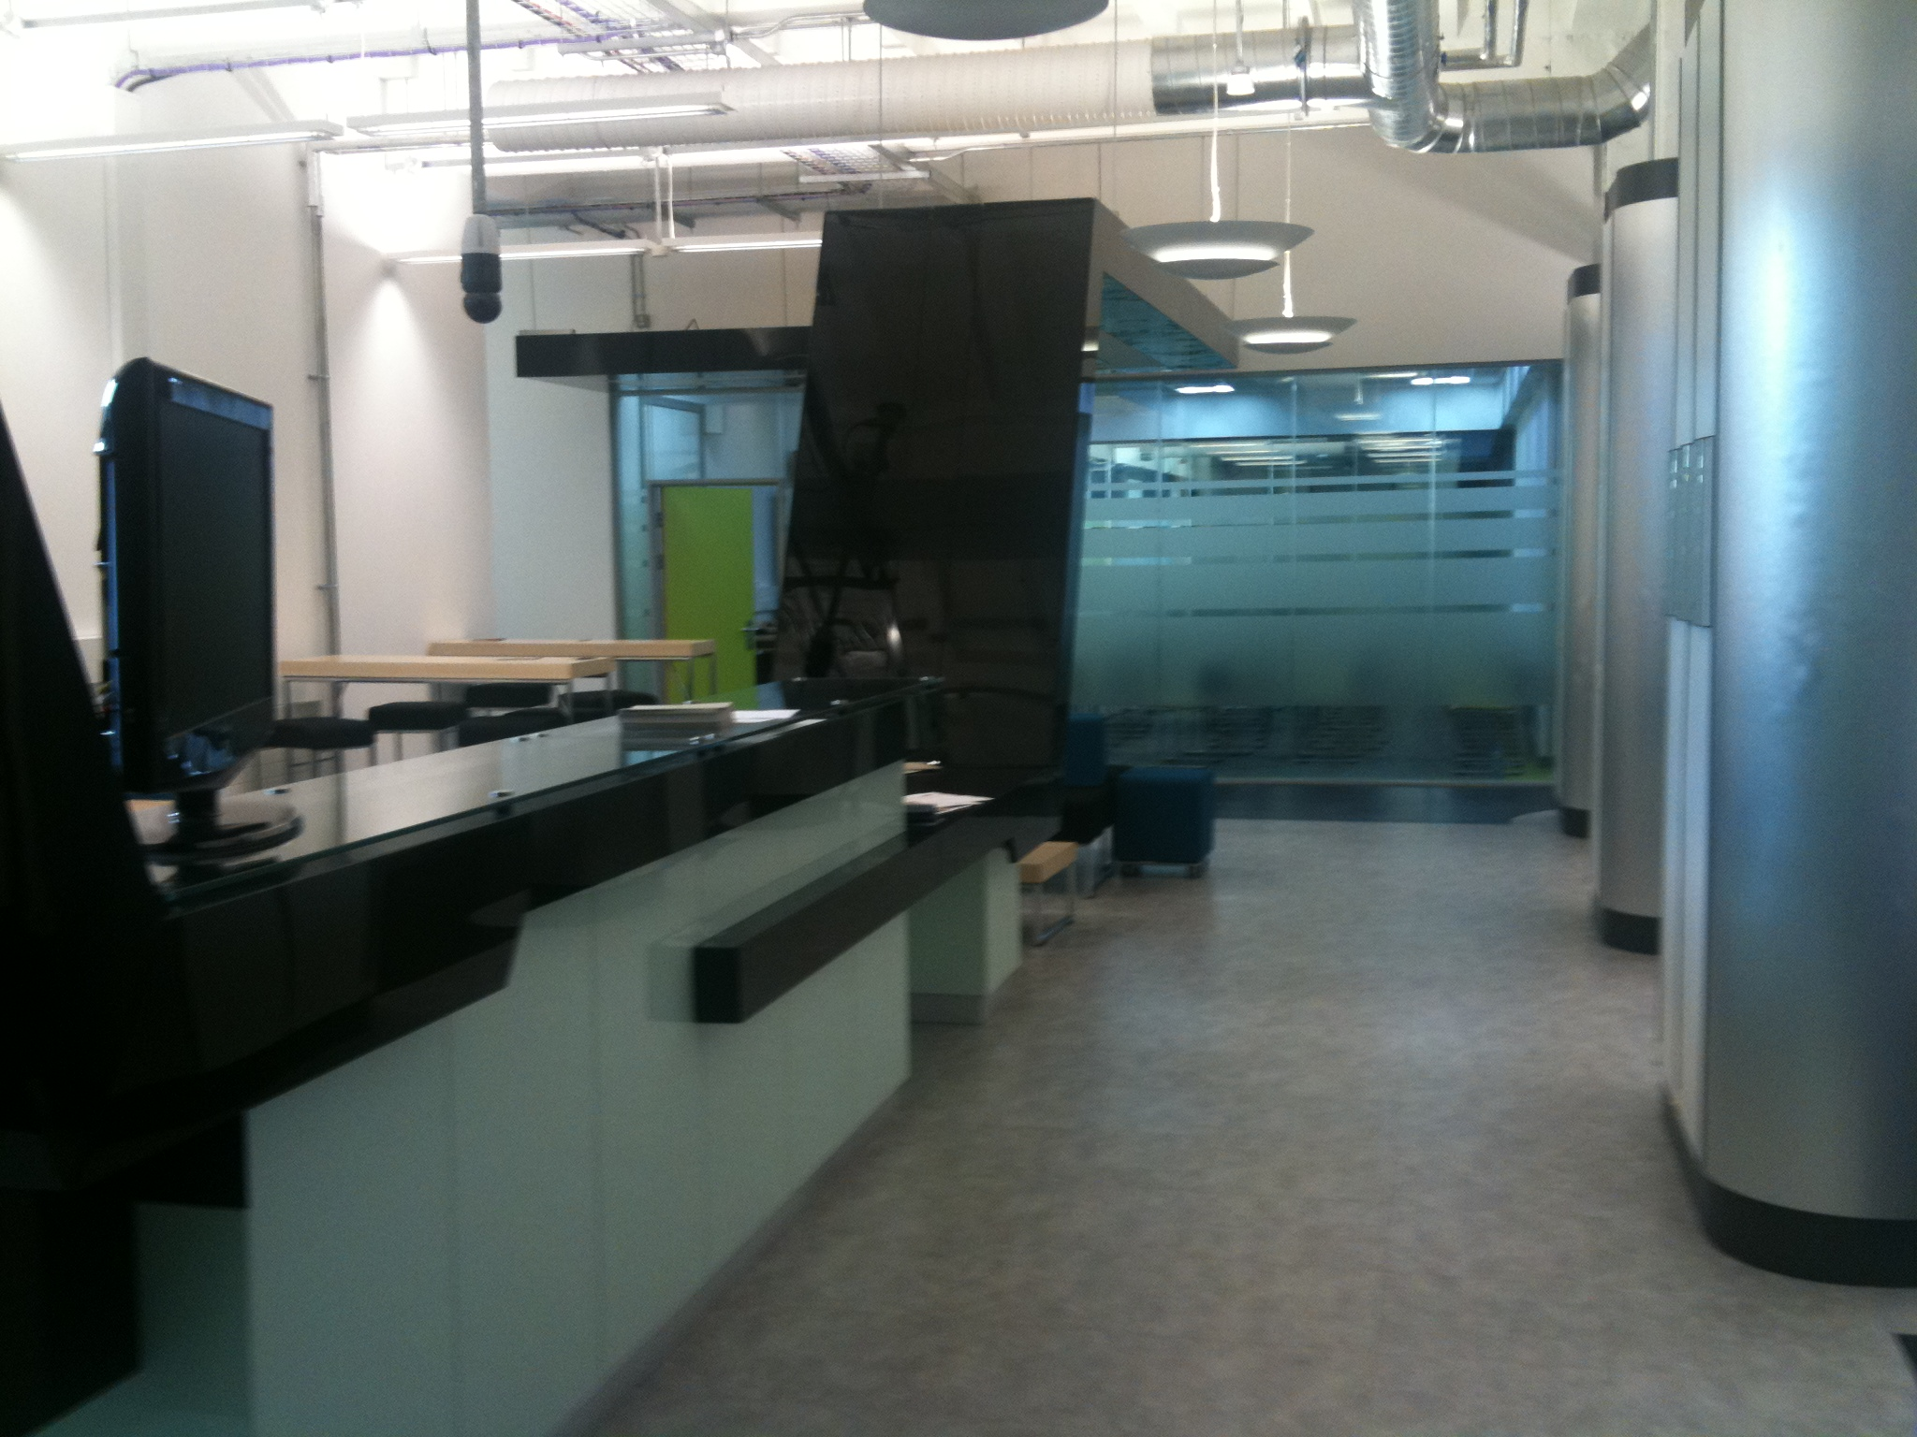

**Figure 1 – A view of the entrance on level 2 of Abertay University**

Remember that you should give due credit to figures that you use by giving a reference after the caption – the above photo is one I took and so I have given myself permission to use it

The next section is the Method section and the two-column format continues.

(Approx ¾ page)

**3. METHOD**

In this section you will describe what practical work you actually intend to carry out. You should mention what choices exist and explain why you have chosen a particular method.

Of course at this point you have not actually done anything and so you are speculating to some extent but by looking at what other people have done (and referencing that work) you should be able to identify what is possible given your own limitations in terms of time and skills.

(Approx ¾ page)

**4. Summary**

You should finish you proposal with a summary of what you see your project as contributing to the subject area. Why is it worth doing and who might benefit from your results?

(Approx ¼ page)

**5. REFERENCES**

All of the references that you have cited in the text must now be listed here in alphabetical order using the Harvard Cite Them Right style of referencing. Again we remind you that guidance is available from

<https://intranet.abertay.ac.uk/library/referencing/>

which explains how to reference all the material you are likely to come across from journal papers to blogs or youtube. The reference you give must enable anyone to obtain the reference, not just people with an Abertay University IT account for example

The reference list should be 9 point Times New Roman but only left justified:

Other, A, N, date, “Title of the article”, *Name of the Journal,* Volume number, pages

See the guides for other examples of style

Note that we expect you to have no more than 8 references but you should have at least 3 good quality references meaning that they have been published in a peer-reviewed journal or other publication (a conference proceedings for example)

Finally, note that we have tried to make the two columns on this last page roughly the same length by inserting blank lines in the first column